Feb 9 | From here on out Teams will coordinate to design the two canvas questions: one on readings, and one personal living story to implement SEAM  Submit your PAP Form all filled in? | Know Figure Six - Psychoanalytic SEAM(deeper theory of SEAM for MBAs  New slides on Hidden Costs by Abdul
Agile pp. 23-36 – TFW virus and how to combat it

SEAM Book chap 6: How to convert HC into value-added and create potential through the SEAM
HORIVERT- implement DPIE on Horizontal (top management) and Vertical (bottom up)
Mirror Effect is fieldnotes, with direct verbatim quotes organized by 4-leaf topics in an DIAGNOSTIC REPORT that includes a FINANCIAL ANALYSIS CHART (see Figure 6.1 in SEAM BOOK) or SEE REPORT TEMPLATE pp. 20-21
Type of Dysfunction cost observed (from the 4 leaves), frequency, reasons for dysfunctions, components of the financial consequences (i.e. root stem types)
- Excess Salary
- Overtime
- Over Consumption of Resources
- Non-Production of goods and services
- Non-Creation of human potential
- Risks that things will get worse and worse
- Table 2 – Report for MIRROR EFFECT Meeting (Required Summary Table of Costs of Keeping Going the Way its Going)
Dysfunction, Structure, Behavior, Hidden Cost OBSERVED | Frequency of Each | Estimated Cost of each Occurrence | SUBTOTAL of Cost & or Untapped Revenue | Reasons for Each | IDENTIFY ROOT-STEM: DOWNWARD ECONOMIC PERFORMANCE SPIRALS
1. HC: Absenteeism | 3 times a week | $50 | $150 | Had to have owner do job of absent printer | Excess Salary
2. Dysfunction: Time Management | 1 time each week | $100 | $100 | Printers wasting time | Overtime
3. Behavior: Conflict of two press operators | 2 times a week | $50 | $100 | Behavior: two operators are fighting | Overconsumption (wasted paper)
4. HC: nonquality | 2 times a week | $500 | $1,000 | Dysfunction: the communication of specs for the job from clerk to printer was wrong | Nonproduction (customer refused job)
5. Behavior: Professional Categories | 1 time a week | $400 | $400 | Dysfunction: Work organization | Noncreation of potential Revenue
6. Dysfunction: Integrated Training | Once a year | $1,000 | $3,000 | Operator not trained on paper cutter; payout in workers’ comp | Risk Spiral: some apprentice lost a finger
TOTALS:  WEEK  MONTH  YEAR TOTAL |  |  | $ 1,750  $ 7,000  $87,000

DPIE includes Mirror Effect: Diagnosis of Root Causes, then MIRROR EFFECT meeting, then Project design, Implementation, & Evaluation
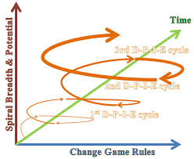
IN PROJECT PLANNING have HORIZONTAL focus group to top management, and VERTICAL focus group at department level (bottom up).
Include Competency Grid Tool, to sort out training needs
COMPETENCY GRID BEFORE THE CHANGE
 | Traditional Competencies in old objectives |  |  |  | New Competencies to be Acquired
WORKERS | Green Product Design | Green Supply Chain | Materials Recycling | Energy Savings | Product Knowledge | Contracts | Project Management | Customer Service
A | ■ | ☐ |  | ☐ | ■ | ☐ | ☐ | ■
B | ☐ | ☐ |  | ☐ | ■ | ☐ | ■ | ■
C | ☐ |  | ■ |  |  |  | ■ | ☐
D | ☐ | ☐ | ■ |  |  | ☐ | ☐
E | ■ | ☐ | ■ | ■ | ■ | ☐ |  | ☐
F | ■ |  | ■ | ■ |  | ☐ | ☐ | ☐

COMPETENCY GRID AFTER THE CHANGE
A | ■ | ■ |  | ■ | ■ | ☐ | ☐ | ■
B | ☐ | ■ |  | ■ | ■ | ☐ | ■ | ■
C | ☐ | ☐ | ■ | ■ |  |  | ■ | ☐
D | ☐ | ☐ | ■ |  | ■ | ☐ | ☐ | ☐
E | ■ | ☐ | ■ | ■ | ■ | ■ | ☐ | ■
F | ■ | ■ | ■ | ■ | ■ | ■ | ☐ | ■

=Frequently Practiced  =Occasional Practiced/Not all Mastered
☐=Knowledge of Principles without Practice BLANK= No Knowledge or Practice

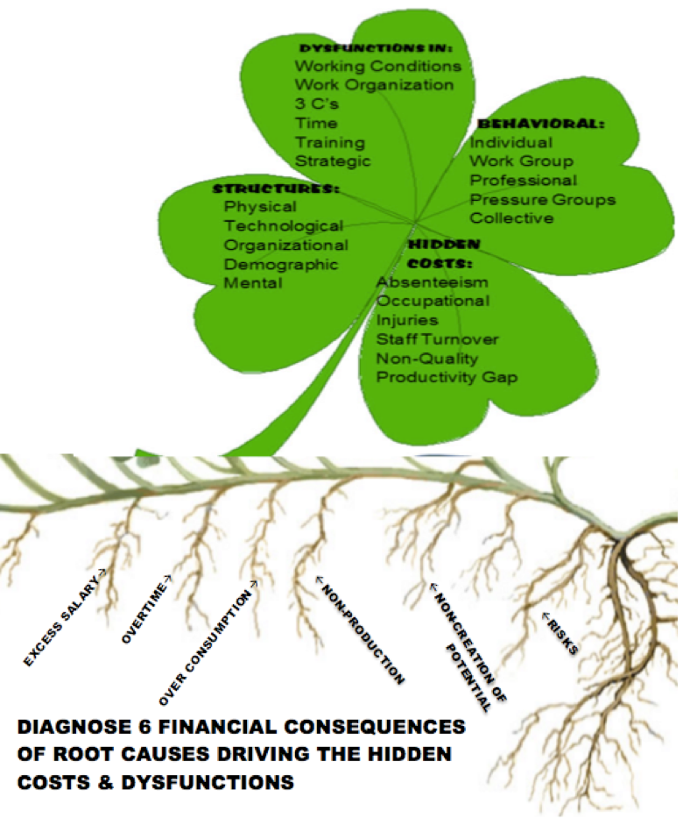
MBA Hidden Costs Ch 2 Evaluating HC
Ethics Book III
In Book III Aristotle is concerned with passions and actions. Some are voluntary: praise (enduring painful) & blame. Involuntary are compulsory (forced), pardon, pity. Throwing goods overboard in story is mixed of involuntary (external circumstance, compelling power) and voluntary. Ignorance is not voluntary. Pain and repentance is involuntary. Acting by reason of ignorance not same as acting in ignorance. Wicked people are ignorant is what one ought to do or abstain from

MBA2 AND UNDERGRAD Team 2 – YouTube, guest, Slides about the book chapters, D-P-I-E progress, & class learning activity Dolesson plan discuss Crowd Sourcing: e.g. GoFundMe at Veterans Theater or Lucky Ant's & RocketHub

